

**SCSJ3253**

**TEKNIK PENGATURCARAAN III**

**PROJECT**

Semester 1 2022/2023

**Lecturer’s Name:**

Prof. Madya. Ts. Dr. Mohd Shahizan Bin Othman

|  |  |
| --- | --- |
| **NAME** | **MATRIC NO** |
| SAVITH RAI | SX180279CSJS04 |
| NUR AINON BINTI YUSMADI | SX172096CSJF04 |
| MOHAMMAD HAFIZZUDDIN BIN MOHD ZIN | SX180405CSJS04 |
| SOBERY BIN BASRI | SX180091CSJS04 |

**Table of Content**

**INTRODUCTION**

Presently, a greater proportion of individuals are relying on the Internet as their main sources of information, particularly news. Most broadcasters operate their own web pages, which they update as soon as new information is made available. It has also emerged clear that such vast amounts of information are frequently too overwhelming for users to sift through in sequence to obtain the one bit of news those who are keen in. Exite.com and Yahoo.com, for example, offer significant alternatives to the concern.

FIFA on the GO is an innovative but audacious digital magazine publications online platform and distribution center based in Kuala Lumpur with a Malaysian audience distributed throughout the country. As a news portal organization, we offer expertise in News, Entertainment, Business, and Sports. Our cutting-edge in-house commentators are housed in a conventional corner piece facility located in the heart of Malaysia. "FIFA on the GO.my" is an all-in-one Web-Application for publishers who want to run an online newspaper.

All content is stored within a database and classified. Classifications are easily customizable and have a self-organized interface for promoting top stories. Software can be managed using a role-based system similar to that of a traditional news article. The emphasis of a role-based framework to keep driving applications in secure mode is on page editors, managers, and assistance, among other things. The content schedule feature enables you to upload publications and news at a more convenient time. All articles on Media News Portal are created and published using optimized for search engines. URLs.

**Objectives**

The objectives of the project are:

1. A role-based sport news system that can be managed like a traditional newspaper.
2. To keep a consistent and well-structured website.
3. To create a website that is updated 24 hours a day, seven days a week.
4. To improve the quality of sport news delivered to users.
5. To create a directory and article search engine.

**Project Aim**

The goal of this project is to create a role-based system that will provide users with quality sports news 24 hours a day, seven days a week.

**Project Scope**

The three categories into which the project's scope can be divided are as follows:

a. Platform

1. This system is a web based system and c# as well as visual basic is used for the development of the web system.

b. Functionality

1. Subscribers can use the web system function to stay up to date on all sport news scores with pinpoint accuracy.
2. The website will be updated seven days a week, 24 hours a day.
3. This system will generate a directory and a search engine for articles.

c. Users

1. This system's users are our paid subscribers who are sports enthusiasts.

**Tools & Technology Used Description**

Tables 3.1, 3.2 and 3.3 are the details of hardware, network and software requirements for the development of FIFA on the GO systems.

**Table 3.1** Hardware requirements for FIFA on the Go systems.

|  |  |
| --- | --- |
| Hardware | Justification |
| Laptop | |  |  | | --- | --- | |  | FIFA on the GO website systems are developed and tested on a laptop. The following are the laptop specifications:  Processor :Intel® CoreTM i5-1135G7  Hard drive : 160 GB minimum  RAM: 8 GB DDR4-3200 SDRAM | |
| Mouse | |  |  | | --- | --- | |  | The device is very important when it comes to computer accessories because it not only makes tasks simpler, quicker, and more convenient to complete. It can increase productivity among system developers because it operates more quickly, intuitively, and precisely than a mousepad. The mouse will be a Logitech. | |
| Keyboard | |  |  | | --- | --- | |  | The keyboard is the most well-known and frequently used input device for entering data in the form of text or numbers. They are incredibly effective, durable, and portable. We'll be using the enhanced keyboard, which has 110 keys. | |
| Monitor | |  |  | | --- | --- | |  | A 20-inch DELL HDMI display will serve as the monitor | |

**Table 3.2** Network requirements for FIFA on the GO systems.

|  |  |
| --- | --- |
| Network | Justification |
| Network & Internet | |  |  | | --- | --- | |  | Local area networks and wireless networks will be used as the main sources. One of the aforementioned network connections is required in order to access FIFA on the Go system | |
| Firewalls & Defender | |  |  | | --- | --- | |  |  |   As a main source, the established firewalls as well as Windows Defender are not required to be changed since this system has been adequately developed so that these security features do not identify FIFA on the GO as a hazard. As the FIFA on the GO system does not necessitate any changes to the current setup during execution of the program, the local antivirus system would be permitted to function as well. |

**3.4.2 Software Requirement**

The software technologies used to construct the FIFA on the Go system are listed in Table 3.3 along with their justifications.

**Table 3.3** Software Requirements for FIFA on the Go system

|  |  |
| --- | --- |
| Software | Justification |
| Operating System | |  |  | | --- | --- | |  | Windows 10 (64 bits) or a later edition of Windows are supported. This Windows operating system is fast, dependable, and works with the majority of third-party devices and applications. | |
| Programming language | |  |  | | --- | --- | |  |  |   HTML, a standard markup language, was used to create web pages. HTML elements are used to design and structure sections, paragraphs, links, and other elements.  CSS is a simple design language which used improve the aesthetic appeal of web pages. It adds a new functionality to HTML.  The CSS Framework Bootstrap is well-known. It was used to build a web-based system that is responsive. It includes typography, forms, buttons, tables, and other design elements in HTML and CSS.  JavaScript is a dynamic programming language. It is lightweight and is most commonly used as a component of web pages, where its implementations allow client-side script to interact with the user and create dynamic pages (JavaScript - Overview, n.d.). It is an object-oriented interpreted programming language. (JavaScript - Overview, n.d.) Java script has several advantages, including richer interfaces, increased interactivity, and extended functionality. The web system was built using JavaScript. (JavaScript - Overview, n.d.) |
| Database | phpMyAdmin is a free PHP-based software tool for managing MySQL over the Internet. Among several other things, phpMyAdmin enables you to manage databases, relationships, tables, columns, indexes, permissions, and users. These operations can be carried out via the user interface, while the user can continue to execute SQL statements. |
| XamppServer | XAMPP is a well-known cross-platform web server that allows developers to build and test applications on a local web server. The Apache Friends created it, and the user can revise or modify the native source code. This straightforward and lightweight solution is cross-platform, supporting Windows, Linux, and Mac. |

**System Requirement Analysis**

The two fundamental components that comprise a system's necessities are both hardware and software. Numerous suitable and appropriate hardware and software are required for a rapid application development process in order to reduce labor costs and development time. The hardware and software requirements for developing the FIFA on the GO system are mentioned above.

c. **System Module**

d. Module Functionality

**4.4 Database Design**

Using an Entity-Relationship Diagram (ERD) and normalised tables, this section outlines the data model for Phishshoo phishing detection system. Admin, Register and Blacklist are the three database tables that are essential for the Phishshoo phishing detection system. The main tables of the detection system's database as well as other tables are presented in Table 4.2.

**Table 4.2** Tables in database of Phishshoo phishing detection system

|  |  |
| --- | --- |
| **Tables** | **Function** |
| Admin | Contain admin basic information |
| Users | Contain users information |
| News | Contain news updates information |
| Feedbacks | Contain user’s feedbacks information |

**Entity-Relationship Diagram (ERD)**

An entity relationship diagram (ERD), often termed an entity relationship model, is a graphical depiction of the connections between the tables in a database's data model. Figure 4.7, includes an ERD diagram of Phishshoo phishing detection system.

**Use Case Diagram**

Figure 4.1 depicts the FIFA on the Go system's use case diagram. The main goal of the use case is to emphasize how the FIFA on the Go system functions as a whole. This use case provides a concise and accurate explanation of the system's behavior. The actor in the use case diagram is the user who will use the system to retrieve on demand unlimited sport news updates.

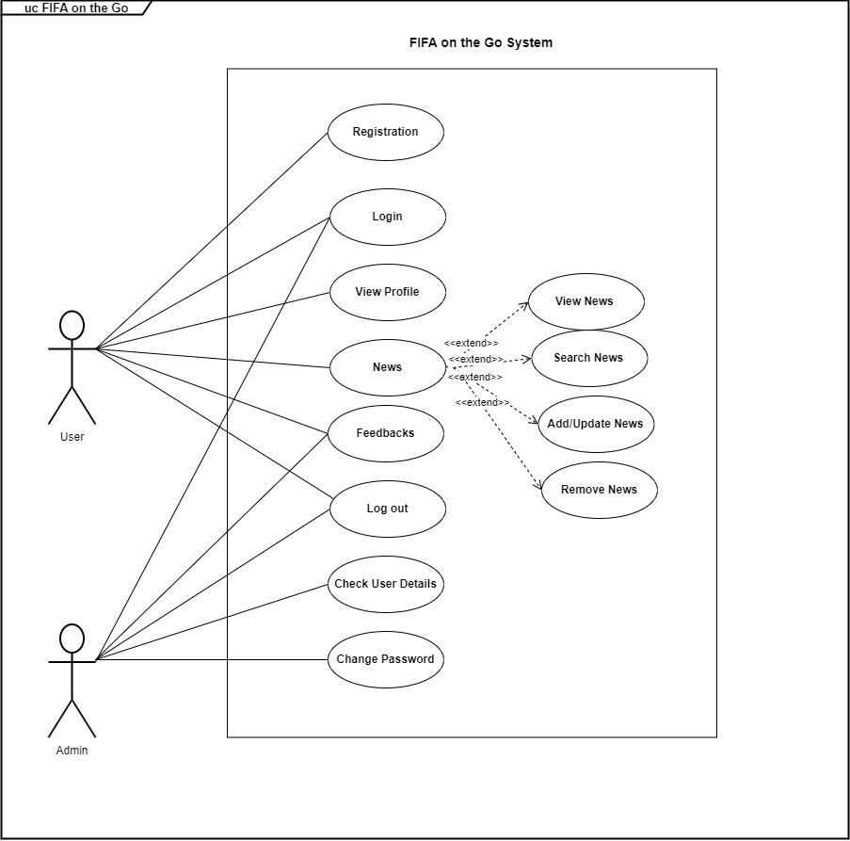

**Figure 4.1** FIFA on the Go Use Case Diagram

**Activity Diagram**

The operational step-by-step processes of components in the FIFA on the GO system are represented in the activity diagram flowchart. This section illustrates the activity flowchart of system, from the register for an account, User login and password for the system access to logout.

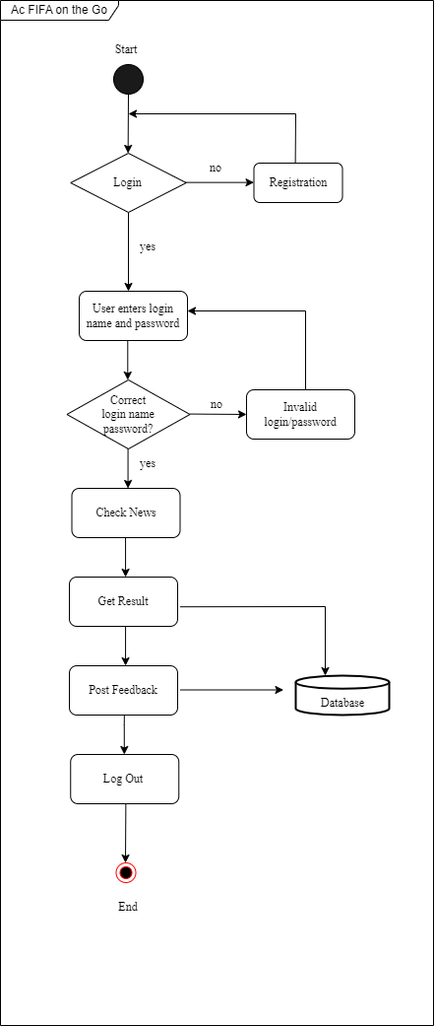

**Figure 4.5** FIFA on the Go system Activity Diagram

**Achievement of Project Objective**

**Suggestion for future achievement**

Based on its limitations, a few suggestions have been made to improve the FIFA on the GO system. The following are some suggestions:

**Conclusion**

In our project work, we attempted to create a news or information-based website. We created this project to assist people and make them aware of current affairs. We use a variety of methodologies to build this website.

All of the project's objectives have been fulfilled. Several challenges were encountered during the project's development. Nonetheless, the required actions and solutions were implemented. The supervisor gave effective supervision and directions in order to complete the task on time. This apart from that, the flaws of the project were highlighted. Finally, several suggestions and proposals for the future improvement of this system were recognized.

**References**